Futuristic Design Challenge
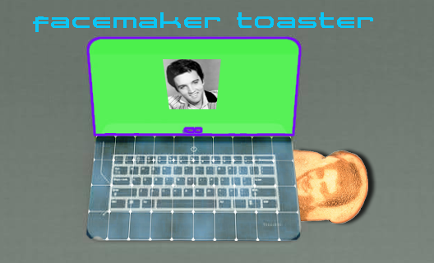

Futuristic Design reflects how we envision a product or event in the future. Imagine a product for the year 2050.

What is a Futurist?
A futurist is a person who studies the future in order to help people understand, anticipate, prepare for and gain advantage from coming changes. It is not the goal of a futurist to predict what will happen in the future. The futurist uses foresight to describe what could happen in the future and, in some cases, what should happen in the future.

The Design Challenge
Create a two page website. The first page is a futuristic advertisement for a product…any product. You can use any images you wish and you are welcome to edit or combine images in Photoshop. The text is totally up to you as are the fonts that you use. Think of this as an ad that might be in a magazine. We’ve only touched the surface with our web design skills so this exercise will pose both technical and artistic challenges. Just do the best you can to recreate the look and feel of a futuristic design.

To create a text link from the first page to the second page named page2.html the code would be:
<a href =page2.html>Design Summary</a>

Answer two questions on your second page page:

- What’s your definition of Futuristic Design?
- What web skills or techniques do you wish you understood to help you execute your design more effectively? For example, maybe you would like to know how to make columns in your advertisement or explore more font options.

This assignment is to be completed for the start of our next class. It must open when we click on your name. Be sure to save and update your blog page and name it blog.html. We’ll be organizing it into our portal for the next class.

The Basic Instructions

Open TextWrangler or Notepad and open a new blank page. We’ll work together to set this up! Have your html5 reference code handy. Start by typing-in the basic framework for a page:

<!DOCTYPE html>
<html lang="en">
<head>
<meta charset="UTF-8" />
<title>Futuristic Design</title>
</head>
<body>
</body>
</html>

Follow the instructions for the exercise above and remember all visible content must be placed between the <body> </body> tags.

Save as index.html (this is your new index page for your webspace when you upload on the server, it will overwrite your blog with the same name. Do you understand why?

Add images to your page with the <img src=name of your image file>. your image file(s) must be a jpg, gif or png and the image must be in the same location as the pages you create. Do you understand why?

To begin creating your second page for this exercise, copy your new index.html and save as page2.html and be sure to save in the same folder. This saves time and code errors since you know the page works. To create a text link from the first page to the second page named page2.html the code would be:<a href =page2.html>Design Summary</a>

How would you get back to the index page?

